**IFT 266 Introduction to Network Information Communication Technology (ICT)   
  
Lab 27**

**IPv6 Autoconfiguration (Wired + Wireless Networks)**

Co-authored by Brayden Alloway + Raymond Baird

This lab practices setup of a wired and wireless networks on separate subnets with IPv6 autoconfiguration.

1. Setup the following topology in Packet Tracer

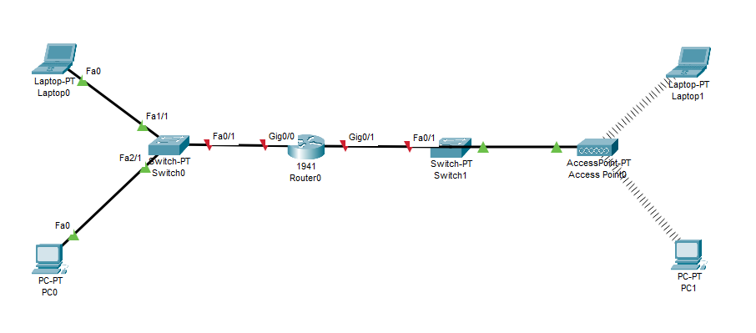



1. For the computers in the wireless network to connect, we must first swap out the network cards in PC1 and Laptop1. PC1 will use a WMP300N and Laptop1 will use a WPC300N.



3. Next, we assign subnet 2001:db8:abcd:a::1/64 to the router g0/0 interface.

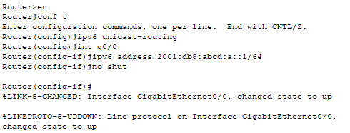



4. Next, we assign subnet 2001:db8:abcd:b::1/64 to the router g0/1 interface.

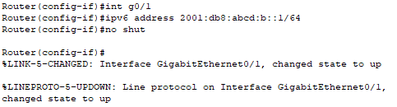



1. Set up WAP2-PSK Authentication on the Access Point. Create SSID name and PSK Pass Phrase. Wireless connection indicators to PC1 and Laptop1 will now be gone from the topology.

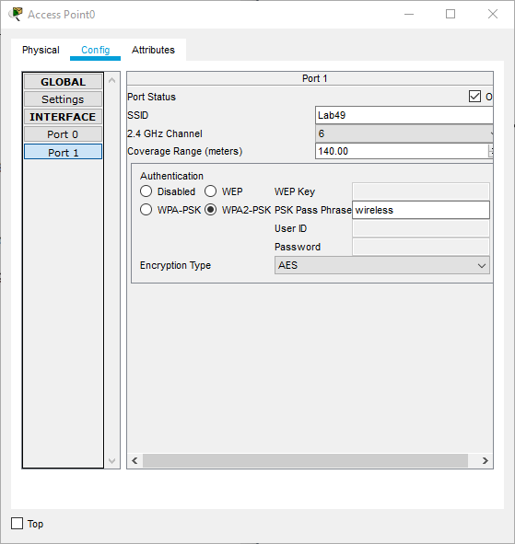



6. Select WAP2-PSK Authentication and enter Pass Phrase and SSID in PC1 and Laptop1.



7. Go to the Desktop and configure IPv6 Configuration as Automatic for all four host computers.



8. Ping PC1 from Laptop0 using the assigned IPv6 address. If unsuccessful, then troubleshoot.

Insert screenshot of successful ping